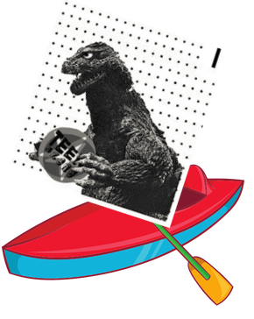
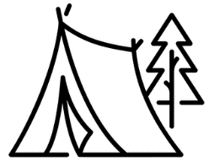
TEEN SZENE OVERNIGHT KAYAKYING TRIP – MAY 2022!
REGISTRATION:
You must pre-register for this trip AND fill out/sign three forms:
#1 - Cortes Kayaks WAIVER form
#2 – CCHA Waiver form
#3 – Kayak Trip Registration Form (on back of this form)
Space is limited so please get your registration in ASAP.
**And all youth coming on the trip must attend Tuesday, May 17th “Introduction to Kayaking” at Mansons Lagoon. (Contact Jodi if you absolutely cannot attend May 17th). See May flyer for details – or check our website:
www.cortesfamily.ca.
*Contact

ESSENTIAL DETAILS:
Cortes Kayaks is taking Teen Szene to Marina Island – by kayak!
Youth must bring their own camping gear (tent, sleeping bag/mat)
All Food/Snacks/Supervision will be provided. Please note any dietary restrictions on the registration form.
Kai and Tosh will be guiding the trip and Kim Lotnik will be the Teen Szene facilitator!

Depart: Saturday, May 28th, 10am – Mansons Lagoon
Pick/Return: Sunday, May 29th, 4pm – Mansons Lagoon

This is an AWESOME opportunity and, like all CCHA Youth Programming, we’re offering it for free to TSZ participants. However, the costs are very high, and we are asking the Cortes Community for donations to help cover the cost of the trip. Please consider inviting your friends and family to make a tax-deductible donation to help us cover the costs. These donations go a long way to help us continue offering free programming to Cortes Island youth.

To donate:

To donate directly on our website, please go to:
www.cortesfamily.ca
And click the DONATE button at the top of the homepage. Please specify “Youth Programs Appeal” in the drop down menu.
This Photo by Unknown Author is licensed under CC BY-SA

To donate in person, drop off cash or cheque to the Cortes Community Health Centre.
Please write “Attention Jenny” on the envelope and leave it with the front desk staff. Include a note mentioning it’s for the CCHA Youth Programs, or CCHA Kayaking Trips, and your contact info if you desire a tax receipt


To donate by mail, please make cheques payable to the Cortes Community Health Association with the memo “Family and Youth Programs” and mail to:
Cortes Community Health Association
PO Box 59
Mansons Landing, BC V0P1K0

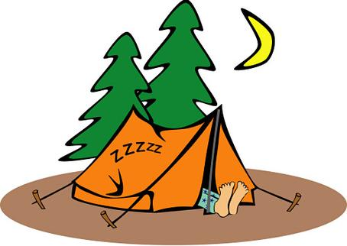
TEEN SZENE MAY 2022 - REGISTRATION FORM
A program of the Cortes Community Health Association

Date:________________________

Name of participant: ___________________________________________________________

Age: _______ Date of birth:_____________ BC health care number:______________________

Medical conditions (previous concussions, medications, injuries?):________________________
______________________________________________________________________________
Allergies/Dietary Restrictions: _____________________________________________________________________
Swimming ability (circle one): Excellent Above Average Average Below average Cannot swim

Parent(s)/Guardian:____________________________________________________________________

Phone:_______________________________ Alternate phone:___________________________
Address:______________________________________________________________________
Email:________________________________________________________________________

Emergency contact person(s):______________________________________________________

Emergency contact number: ______________________________________________________

Questions/Concerns? Email Youth Programs Manager Jodi Peters: ccha.programs@gmail.com

